2023 BULAHDELAH SHOW

JUNIOR/NOVICE RODEO – FRIDAY 17th NOVEMBER 2023

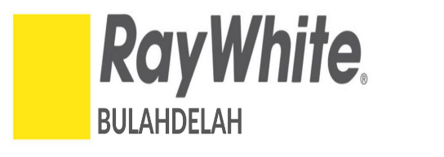
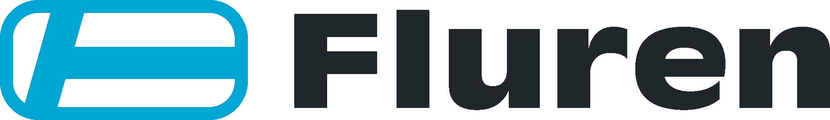

PLATINUM SPONSORS

N.B. Rodeo Events commencing approximately 6.00pm

Points Awarded
HELMETS CAN SAVE LIVES

1. Novice Bull Ride - $800 Entry Fee: $98
Sponsors: R & J Dixon –Bulahdelah Post Office & Gooch Agencies
Access Fuels & Coastal Earthmoving Hire P/L
$296 $216 $152 $80 $56

2. Junior Bull Ride - $600 (14yrs to Under 18yrs) Entry Fee: $56
Sponsors: TJ & JL Mason
$222 $162 $114 $60 $42

3. Mini Bull Ride - $450 (11yrs to under 14yrs) Entry Fee: $48
Sponsors: Access Fuels/Bulahdelah Golf Club & Coastal Earthmoving Hire P/L
$166.50 $121.50 $85.50 $45 $31.50

4. Mini Bull Ride - $400 (8yrs and under 11yrs) Entry Fee: $40
Fluren Ray White – Bulahdelah Bulahdelah Golf Club
S148 $108 $76 $40 $28

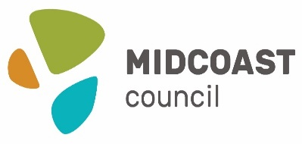
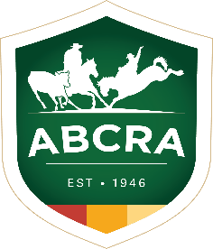

**** Enquiries for Rodeo to:
Bernadette Newton - 0456468437 - After 6.00pm

**** ABCRA Affiliated

**** Entries via ABCRA Icompete

**** Bulahdelah Show Society Inc. Waiver Forms to accompany entries

**** The Committee reserves the right to change the programme or refuse any nomination for
any Event
**** N.B. - All Novice & Junior Competitors MUST wear a fully enclosed (Cage Fronted) Helmet in Steer Riding and Bull Riding Events

**** NO ALCOHOL OR GLASS TO BE BROUGHT ONTO THE SHOWGROUNDS

**** NO DOGS ALLOWED – unless they are assistance dogs or competing in a scheduled show event
must be kept on a lead

